Linked List Creation and Traversal

/**
* C program to create and traverse a Linked List
*/

#include <stdio.h>
#include <stdlib.h>

struct node {
int data;
struct node *next;
}*head;

void createList(int n);
void traverseList();

int main()
{
int n;

printf("Enter the total number of nodes: ");
scanf("%d", &n);

createList(n);

printf("\nData in the list \n");
traverseList();

return 0;
}

void createList(int n)
{
struct node *newNode, *temp;
int data, i;

head = (struct node *)malloc(sizeof(struct node));

if(head == NULL)
{
printf("Unable to allocate memory.");
exit(0);
}

printf("Enter the data of node 1: ");
scanf("%d", &data);

head->data = data;
head->next = NULL;

temp = head;
for(i=2; i<=n; i++)
{
newNode = (struct node *)malloc(sizeof(struct node));

if(newNode == NULL)
{
printf("Unable to allocate memory.");
break;
}

printf("Enter the data of node %d: ", i);
scanf("%d", &data);

newNode->data = data;
newNode->next = NULL;

temp->next = newNode;
temp = temp->next;
}
}

void traverseList()
{
struct node *temp;

if(head == NULL)
{
printf("List is empty.");
return;
}

temp = head;
while(temp != NULL)
{
printf("Data = %d\n", temp->data);
temp = temp->next;
}
}

Output:
Enter the total number of nodes:3
Enter the data of node 1:10
Enter the data of node 2:20
Enter the data of node 3:30

Data in the list
Data:10
Data:20
Data:30
Linked List Insertion
1.At beginning:
/**
* C program to insert a new node at the beginning of a Singly Linked List
*/

#include <stdio.h>
#include <stdlib.h>

/* Structure of a node */
struct node {
int data; // Data
struct node *next; // Address
}*head;

void createList(int n);
void insertNodeAtBeginning(int data);
void displayList();

int main()
{
int n, data;

/*
* Create a singly linked list of n nodes
*/
printf("Enter the total number of nodes: ");
scanf("%d", &n);
createList(n);

printf("\nData in the list \n");
displayList();

/*
* Insert data at the beginning of the singly linked list
*/
printf("\nEnter data to insert at beginning of the list: ");
scanf("%d", &data);
insertNodeAtBeginning(data);

printf("\nData in the list \n");
displayList();

return 0;
}

/*
* Create a list of n nodes
*/
void createList(int n)
{
struct node *newNode, *temp;
int data, i;

head = (struct node *)malloc(sizeof(struct node));

/*
* If unable to allocate memory for head node
*/
if(head == NULL)
{
printf("Unable to allocate memory.");
}
else
{
/*
* Input data of node from the user
*/
printf("Enter the data of node 1: ");
scanf("%d", &data);

head->data = data; // Link data field with data
head->next = NULL; // Link address field to NULL

temp = head;

/*
* Create n nodes and adds to linked list
*/
for(i=2; i<=n; i++)
{
newNode = (struct node *)malloc(sizeof(struct node));

/* If memory is not allocated for newNode */
if(newNode == NULL)
{
printf("Unable to allocate memory.");
break;
}
else
{
printf("Enter the data of node %d: ", i);
scanf("%d", &data);

newNode->data = data; // Link data field of newNode with data
newNode->next = NULL; // Link address field of newNode with NULL

temp->next = newNode; // Link previous node i.e. temp to the newNode

temp = temp->next;
}
}

printf("SINGLY LINKED LIST CREATED SUCCESSFULLY\n");
}
}

/*
* Create a new node and inserts at the beginning of the linked list.
*/
void insertNodeAtBeginning(int data)
{
struct node *newNode;

newNode = (struct node*)malloc(sizeof(struct node));

if(newNode == NULL)
{
printf("Unable to allocate memory.");
}
else
{
newNode->data = data; // Link data part
newNode->next = head; // Link address part

head = newNode; // Make newNode as first node

printf("DATA INSERTED SUCCESSFULLY\n");
}
}

/*
* Display entire list
*/
void displayList()
{
struct node *temp;

/*
* If the list is empty i.e. head = NULL
*/
if(head == NULL)
{
printf("List is empty.");
}
else
{
temp = head;
while(temp != NULL)
{
printf("Data = %d\n", temp->data); // Print data of current node
temp = temp->next; // Move to next node
}
}
}

Output:
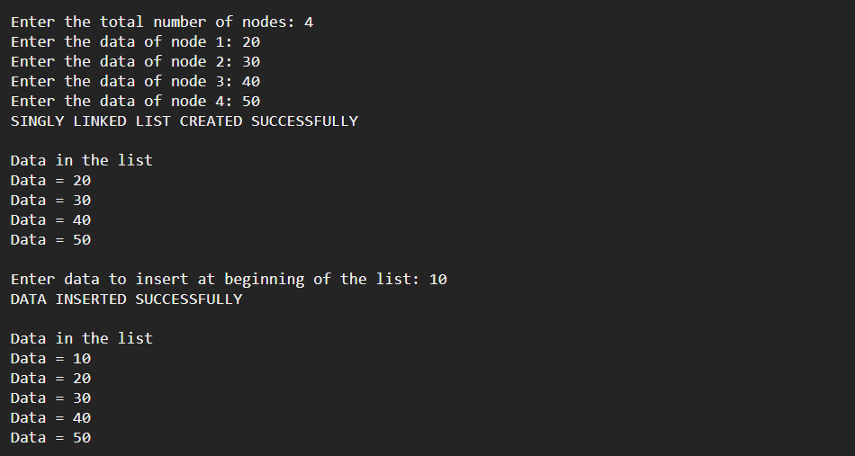
At Middle:
/**
* C program to insert new node at the middle of Singly Linked List
*/

#include <stdio.h>
#include <stdlib.h>

/* Structure of a node */
struct node {
int data; // Data
struct node *next; // Address
}*head;

void createList(int n);
void insertNodeAtMiddle(int data, int position);
void displayList();

int main()
{
int n, data, position;

/*
* Create a singly linked list of n nodes
*/
printf("Enter the total number of nodes: ");
scanf("%d", &n);
createList(n);

printf("\nData in the list \n");
displayList();

/*
* Insert data at middle of the singly linked list
*/
printf("nEnter data to insert at middle of the list: ");
scanf("%d", &data);
printf("Enter the position to insert new node: " );
scanf("%d", &position);
insertNodeAtMiddle(data, position);

printf("\nData in the list \n");
displayList();

return 0;
}

/*
* Create a list of n nodes
*/
void createList(int n)
{
struct node *newNode, *temp;
int data, i;

head = (struct node *)malloc(sizeof(struct node));

/*
* If unable to allocate memory for head node
*/
if(head == NULL)
{
printf("Unable to allocate memory.");
}
else
{
/*
* Input data of node from the user
*/
printf("Enter the data of node 1: ");
scanf("%d", &data);

head->data = data; // Link the data field with data
head->next = NULL; // Link the address field to NULL

temp = head;

/*
* Creates n nodes and adds to linked list
*/
for(i=2; i<=n; i++)
{
newNode = (struct node *)malloc(sizeof(struct node));

/* If memory is not allocated for newNode */
if(newNode == NULL)
{
printf("Unable to allocate memory.");
break;
}
else
{
printf("Enter the data of node %d: ", i);
scanf("%d", &data);

newNode->data = data; // Link the data field of newNode with data
newNode->next = NULL; // Link the address field of newNode with NULL

temp->next = newNode; // Link previous node i.e. temp to the newNode
temp = temp->next;
}
}

printf("SINGLY LINKED LIST CREATED SUCCESSFULLY\n");
}
}

/*
* Creates a new node and inserts at middle of the linked list.
*/
void insertNodeAtMiddle(int data, int position)
{
int i;
struct node *newNode, *temp;

newNode = (struct node*)malloc(sizeof(struct node));

if(newNode == NULL)
{
printf("Unable to allocate memory.");
}
else
{
newNode->data = data; // Link data part
newNode->next = NULL;

temp = head;

/*
* Traverse to the n-1 position
*/
for(i=2; i<=position-1; i++)
{
temp = temp->next;

if(temp == NULL)
break;
}

if(temp != NULL)
{
/* Link address part of new node */
newNode->next = temp->next;

/* Link address part of n-1 node */
temp->next = newNode;

printf("DATA INSERTED SUCCESSFULLY\n");
}
else
{
printf("UNABLE TO INSERT DATA AT THE GIVEN POSITION\n");
}
}
}

/*
* Display entire list
*/
void displayList()
{
struct node *temp;

/*
* If the list is empty i.e. head = NULL
*/
if(head == NULL)
{
printf("List is empty.");
}
else
{
temp = head;
while(temp != NULL)
{
printf("Data = %d\n", temp->data); // Print data of current node
temp = temp->next; // Move to next node
}
}
}

Output: 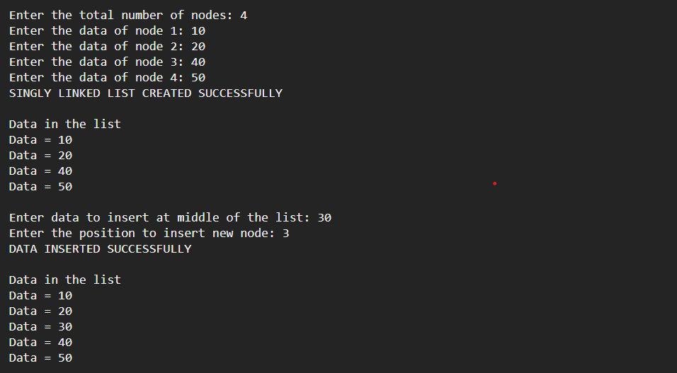

At End:
/**
* C program to insert new node at the end of a Singly Linked List
*/

#include <stdio.h>
#include <stdlib.h>

/* Structure of a node */
struct node {
int data; // Data
struct node *next; // Address
}*head;

void createList(int n);
void insertNodeAtEnd(int data);
void displayList();

int main()
{
int n, data;

/*
* Create a singly linked list of n nodes
*/
printf("Enter the total number of nodes: ");
scanf("%d", &n);
createList(n);

printf("\nData in the list \n");
displayList();

/*
* Insert data at the end of the singly linked list
*/
printf("\nEnter data to insert at end of the list: ");
scanf("%d", &data);
insertNodeAtEnd(data);

printf("\nData in the list \n");
displayList();

return 0;
}

/*
* Create a list of n nodes
*/
void createList(int n)
{
struct node *newNode, *temp;
int data, i;

head = (struct node *)malloc(sizeof(struct node));

/*
* If unable to allocate memory for head node
*/
if(head == NULL)
{
printf("Unable to allocate memory.");
}
else
{
/*
* Reads data of node from the user
*/
printf("Enter the data of node 1: ");
scanf("%d", &data);

head->data = data; // Link the data field with data
head->next = NULL; // Link the address field to NULL

temp = head;

/*
* Create n nodes and adds to linked list
*/
for(i=2; i<=n; i++)
{
newNode = (struct node *)malloc(sizeof(struct node));

/* If memory is not allocated for newNode */
if(newNode == NULL)
{
printf("Unable to allocate memory.");
break;
}
else
{
printf("Enter the data of node %d: ", i);
scanf("%d", &data);

newNode->data = data; // Link the data field of newNode with data
newNode->next = NULL; // Link the address field of newNode with NULL

temp->next = newNode; // Link previous node i.e. temp to the newNode
temp = temp->next;
}
}

printf("SINGLY LINKED LIST CREATED SUCCESSFULLY\n");
}
}

/*
* Create a new node and inserts at the end of the linked list.
*/
void insertNodeAtEnd(int data)
{
struct node *newNode, *temp;

newNode = (struct node*)malloc(sizeof(struct node));

if(newNode == NULL)
{
printf("Unable to allocate memory.");
}
else
{
newNode->data = data; // Link the data part
newNode->next = NULL;

temp = head;

// Traverse to the last node
while(temp != NULL && temp->next != NULL)
temp = temp->next;

temp->next = newNode; // Link address part

printf("DATA INSERTED SUCCESSFULLY\n");
}
}

/*
* Display entire list
*/
void displayList()
{
struct node *temp;

/*
* If the list is empty i.e. head = NULL
*/
if(head == NULL)
{
printf("List is empty.");
}
else
{
temp = head;
while(temp != NULL)
{
printf("Data = %d\n", temp->data); // Print data of current node
temp = temp->next; // Move to next node
}
}
}

Output:
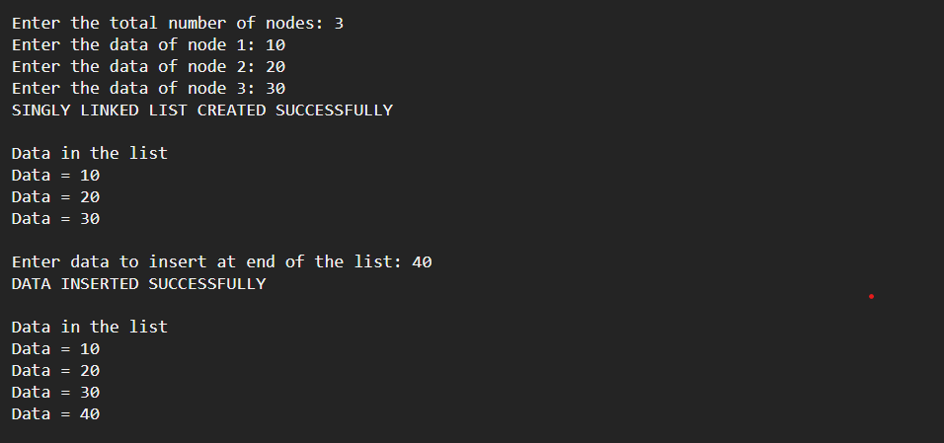

Linked List Deletion
From beginning:
// C program
// to deletion in
// singly linked list
#include <stdio.h>
#include <stdlib.h>

// A linked list node
struct Node {
int data;
struct Node* next;
};

/* Given a reference (pointer to pointer) to the head of a
list and an int, inserts a new node on the front of the
list. */
void push(struct Node** head_ref, int new_data)
{
struct Node* new_node
= (struct Node*)malloc(sizeof(struct Node));
new_node->data = new_data;
new_node->next = (*head_ref);
(*head_ref) = new_node;
}

/* Given a reference (pointer to pointer) to the head of a
list and a key, deletes the first occurrence of key in
linked list */
void deleteNode(struct Node** head_ref, int key)
{
// Store head node
struct Node *temp = *head_ref, *prev;

// If head node itself holds the key to be deleted
if (temp != NULL && temp->data == key) {
*head_ref = temp->next; // Changed head
free(temp); // free old head
return;
}

// Search for the key to be deleted, keep track of the
// previous node as we need to change 'prev->next'
while (temp != NULL && temp->data != key) {
prev = temp;
temp = temp->next;
}

// If key was not present in linked list
if (temp == NULL)
return;

// Unlink the node from linked list
prev->next = temp->next;

free(temp); // Free memory
}

// This function prints contents of linked list starting
// from the given node
void printList(struct Node* node)
{
while (node != NULL) {
printf(" %d ", node->data);
node = node->next;
}
}

// Driver code
int main()
{
/* Start with the empty list */
struct Node* head = NULL;

push(&head, 7);
push(&head, 1);
push(&head, 3);
push(&head, 2);

puts("Created Linked List: ");
printList(head);
deleteNode(&head, 1);
puts("Linked List after Deletion of 1: ");
printList(head);
return 0;
}

Output:
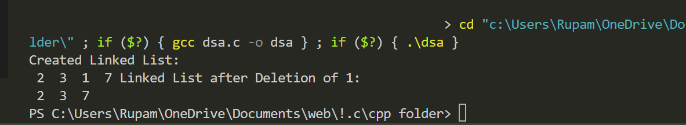
From middle:
// C program to delete middle of a linked list

#include <stdio.h>
#include <stdlib.h>

/* Link list Node */
typedef struct Node {
int data;
struct Node* next;
} Node;

// count of nodes
int countOfNodes(Node* head)
{
int count = 0;
while (head != NULL) {
head = head->next;
count++;
}
return count;
}

// Deletes middle node and returns
// head of the modified list
Node* deleteMid(Node* head)
{
// Base cases
if (head == NULL)
return NULL;
if (head->next == NULL) {
free(head);
return NULL;
}
Node* copyHead = head;
// Find the count of nodes
int count = countOfNodes(head);
// Find the middle node
int mid = count / 2;
// Delete the middle node
while(mid-->1)
head = head->next;
// Delete the middle node
head->next = head->next->next;
return copyHead;
}

// A utility function to print
// a given linked list
void printList(Node* ptr)
{
while (ptr != NULL) {
printf("%d ->", ptr->data);
ptr = ptr->next;
}
printf("NULL\n");
}

// Utility function to create a new node.
Node* newNode(int data)
{
Node* temp = (Node*)malloc(sizeof(Node));
temp->data = data;
temp->next = NULL;
return temp;
}

/* Driver program to test above function*/
int main()
{
/* Start with the empty list */
Node* head = newNode(1);
head->next = newNode(2);
head->next->next = newNode(3);
head->next->next->next = newNode(4);

printf("Given Linked List\n");
printList(head);
head = deleteMid(head);
printf("Linked List after deletion of middle\n");
printList(head);
return 0;
}

Output:
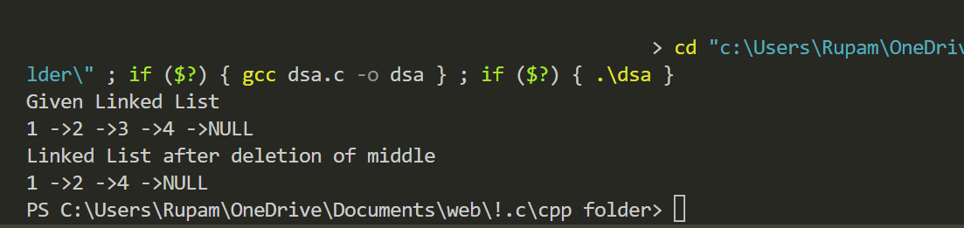
From End:
//C Code for deletion at the end of the Singly Linked List:-
#include<stdio.h>
#include<stdlib.h>

struct Node
{
int data;
struct Node *next;
};

void deleteEnd (struct Node **head)
{
struct Node *temp = *head;
struct Node *previous;

// if there are no nodes in Linked List can't delete
if (*head == NULL)
{
printf ("Linked List Empty, nothing to delete");
return;
}

// if Linked List has only 1 node
if (temp->next == NULL)
{
printf ("%d deleted\n", (*head)->data);
*head = NULL;
return;
}

// else traverse to the last node
while (temp->next != NULL)
{
// store previous link node as we need to change its next val
previous = temp;
temp = temp->next;
}
// Curr assign 2nd last node's next to Null
previous->next = NULL;
// delete the last node
printf ("%d deleted\n", temp->data);
free (temp);
// 2nd last now becomes the last node
}

void display (struct Node *node)
{

// as linked list will end when Node is Null
while (node != NULL)
{
printf ("%d ", node->data);
node = node->next;
}
printf ("\n\n");
}

int main ()
{
//creating 4 pointers of type struct Node
//So these can point to address of struct type variable
struct Node *head = NULL;
struct Node *node2 = NULL;
struct Node *node3 = NULL;
struct Node *node4 = NULL;
struct Node *node5 = NULL;
struct Node *node6 = NULL;

// allocate 3 nodes in the heap
head = (struct Node *) malloc (sizeof (struct Node));
node2 = (struct Node *) malloc (sizeof (struct Node));
node3 = (struct Node *) malloc (sizeof (struct Node));
node4 = (struct Node *) malloc (sizeof (struct Node));
node5 = (struct Node *) malloc (sizeof (struct Node));
node6 = (struct Node *) malloc (sizeof (struct Node));

head->data = 2; // data set for head node
head->next = node2; // next pointer assigned to address of node2

node2->data = 4;
node2->next = node3;

node3->data = 6;
node3->next = node4;

node4->data = 8;
node4->next = node5;

node5->data = 10;
node5->next = node6;

node6->data = 12;
node6->next = NULL;

printf ("Linked list: ");
display (head);

deleteEnd (&head);
deleteEnd (&head);

printf ("\nLinked list: ");
display (head);

return 0;
}

Output:

